**Fix Federal Debt Forever**

**PRELUDE**

When in the course of human events, it becomes obvious that our country’s irresponsible fiscal path is highly likely to lead to upheavals, the people must assert their authority. They must insist that the federal government take actions that will ensure that the fiscal path forward is sound and is permanent.

Without rational and adequate fiscal changes, calamitous upheavals will come in Social Security, Medicare, Medicaid, the ability of America to defend itself militarily, and everything else for which the federal government is responsible. They all require money. How much money does our government have now? None. It owes over $28 trillion – or $28 million millions. That is $28,000,000,000,000 or $83,000+ per person.

**IS THE GROWING U.S. FEDERAL DEBT A RISK?**

Absolutely! Experts agree that our path is unsustainable. See the references section below to learn more.

The measure many economists use to assess fiscal risk is the ratio of Debt Held by the Public/GDP. This debt is the amount owed to holders of the debt (mostly Treasure bonds), and GDP is Gross National Product, the total goods and services produced by our economy. So, the ratio compares federal debt to the strength of the nation’s economy to pay the interest and pay off the bonds when they come due.

The risk is that eventually bondholders will become apprehensive that the government may become unable to pay the interest or repay the bonds, and then they will do what debt holders always do, raise the interest rates substantially or just refuse to buy any more bonds…and the sky falls in upon us.

In addition, other countries will lose respect for America. The dollar might cease to be the standard for world trade and banking. And more…

**HOW DOES EXCESSIVE FEDERAL DEBT AFFECT ME AND MY FAMILY?**

Each annual deficit is added to the federal debt. This increases the amount of debt yearly on which interest payments must be made. Interest costs then escalate, competing with everything else for which the government pays, including the medical programs, education, defense, salaries, and more. Social Security gets some monies from payroll deductions of working Americans, but that fund will run dry in eight years, and Social Security payments will have to be reduced significantly. Also, remember that the fund does not have cash in it, but just more bonds representing the borrowing it had to do to replace the cash long spent long ago.

Who supplies almost all of the monies? Ultimately, we citizens, through taxes we pay and indirectly through purchases from businesses that then pay taxes. Excessive federal spending causes the problems described in the paragraph above. In the past few years, annual federal spending has been around $6 trillion, of which $1-2 trillion has been borrowed, namely deficits. The point is, we are ultimately on the hook for the federal debt.

Families understand very well the impact of too much debt on their ability to buy food, clothing, education, and much more. Fortunately, lenders usually refuse to lend them more than they can afford. So far, that process hasn’t happened to the government’s borrowing, so it continued and the interest costs escalated.

**IS THE DEBT ISSUE URGENT?**

Yes! It is long overdue for action.

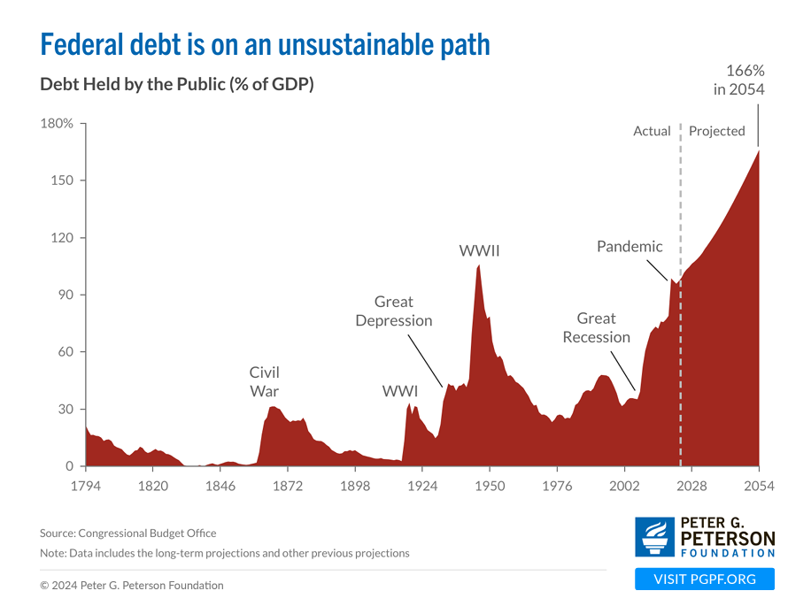

**Our debt-to-GDP ratio is about the same as at the end of WWII.**

**In 30 years, we brought it down to a reasonable number. It is time to repeat that discipline.**

**Ratio Debt/GDP 2010 56 % Growing Problem**

**Ratio Debt/GDP 2024 96 % Perilous Problem**

Manhattan Institute, [A Comprehensive Federal Budget Plan to Avert a Debt Crisis | Manhattan Institute](https://manhattan.institute/article/a-comprehensive-federal-budget-plan-to-avert-a-debt-crisis-2024)

**Clear indication how the interest payments for the “mandatory” programs of Social Security and Medicare are crowding out the rest of the federal budget.**

**Funding Medicare from the General Revenue reduces the amounts available to spend on discretionary items like defense, welfare, climate change, and much more.**

**If and when Social Security payments to retirees are no longer funded by the payroll deductions of those employed, they must be halted or paid from General Revenue funds.**

**Like Medicare, with the same effects. See above.**

**The clock is ticking.**

**We should have taken effective action years ago.**

**Problem and Objectives**

**Problem:**

Most voters and many Members of Congress are inadequately informed about the adverse consequences of continuing on our current federal fiscal path, and Congress has failed to take concrete actions to **defuse our ticking federal debt bomb**.

**Objectives:**

Increase awareness among voters and Members of Congress to the dangers of continuing on our current fiscal path, and get the Congress to take concrete actions to defuse our ticking federal debt bomb.

**What America must do**

There is a growing consensus that a group of experts formed as a Congressional Commission is necessary to develop the plan for a sustainable fiscal path. This may take over a year. Then the Commission will present the plan to Congress to become legislation with few or no changes allowed.

In parallel, support efforts to pass a constitutional amendment to prevent future Congresses from avoiding or repealing key features of the law to result in permanency of a rational fiscal policy for our nation. Most of the work has already been done. See [Home - Federal Fiscal Sustainability Foundation, Inc.](https://ffsf.us/)

**What will cause members of Congress to solve this problem permanently?**

Senators and Representatives will make this their top priority only they are convinced that it is a vital important matter to their constituents. Only when they know that we voters are convinced that our country is facing a ruthless fate will they fix the problem correctly.

**What should I do?**

We citizens must regain control of America; it is our right and duty.

Contact your Senators and Representative! Tell them how you feel. Tell them the honest reason(s) why you feel strongly about getting the federal debt under permanent control. Is it the viability of Social Security? Medicare? Medicaid? National defense? Disability insurance? The type of country in which your children and grandchildren will live? Nostalgia? An edification that you deserve for Congress to fix major problems, especially ones that it created?

Send this website to your friends and relatives.

**How do I contact my Senators or Representative?**

Contact them by writing a personal letter, authoring an email, or telephoning their offices in Washington, DC or in your home state. Using email is easy and fast, and you can repeat it as often as you want. A staff member will almost always receive your email or telephone call. It is reasonable to assume that this staff person might forward a sincere communication to a more senior staff member. More likely, the essence of your message will become a statistic on a list of issues constituents are advocating. Don’t think this is not important; it is very important. Members of Congress want to get reelected, so they do pay attention to issues for which they are receiving a lot of requests.

Steps:

* Type the member’s name into your Internet search engine
* Select the website that has .senate.gov or .house.gov
* Find and click on “Contact *John Doe*…”
* Complete the form. Once you have written a member once, the form remembers many of your answers for the next time. Please include a link to this Federal Debt website since it has information supporting your request.
* When you come to the blank for your message, it is best if you have previously typed it into a document on your computer and checked it for errors. Then, you can cut and paste it into the contact page and use it for your other two members of Congress.
* Complete the form and “Submit.” You will not have a copy of your message unless you did the previous step.
* If you want to telephone, you can find telephone numbers on this same website.

**References with Links**

* David M. Walker. *America in 2040: Still a Superpower? A Pathway to Success*, 2024,

[www.Americain2040.com](http://www.Americain2040.com)

* Brian Riedl. *A Comprehensive Federal Budget Plan to Avert a Debt Crisis*, 2024,

[A Comprehensive Federal Budget Plan to Avert a Debt Crisis | Manhattan Institute](https://manhattan.institute/article/a-comprehensive-federal-budget-plan-to-avert-a-debt-crisis-2024)

* Peter G. Petersen Foundation, [PowerPoint Presentation](https://www.pgpf.org/sites/default/files/PGPF-Chart-Pack.pdf)
* H.R. 5779, the *Fiscal Commission Act of 2023,* [Text - H.R.5779 - 118th Congress (2023-2024): Fiscal Commission Act of 2023 | Congress.gov | Library of Congress](https://www.congress.gov/bill/118th-congress/house-bill/5779/text)
* Congressional Research Service re Why Use Congressional Commissions, [R40076](https://crsreports.congress.gov/product/pdf/R/R40076)
* Debt Clock, <https://www.usdebtclock.org/>